Syed Muhammad Akbar (CS 7B)

237544

Abstract

The aim of the assignment is to get familiarize with Open Source Software. X-cart was thoroughly explored with the user perspective. Different plugins/modules were also added to increase the basic functionality

Advance programming

Assignment # 01

assignment # 01

# X-Cart:

X-cart is an open source platform specially designed for ecommerce websites. It was the first ever PHP shopping cart software to be released. It was release in 2000 by the Russian company Creative Technologies. X-cart advertises themselves as extremely flexible with tons of features and integrations available.

X-Cart is used by over 38,000 e-stores and has a gross merchandise volume of $3 Billion +.

# Pre-installations:

The early attempts to install X-cart open source software in the XAMPP server failed. The problem seemed to went away after the XAMPP server was updated to the latest version.

# Installation:

After fulfilling the requirements, the software package was downloaded from the official website.

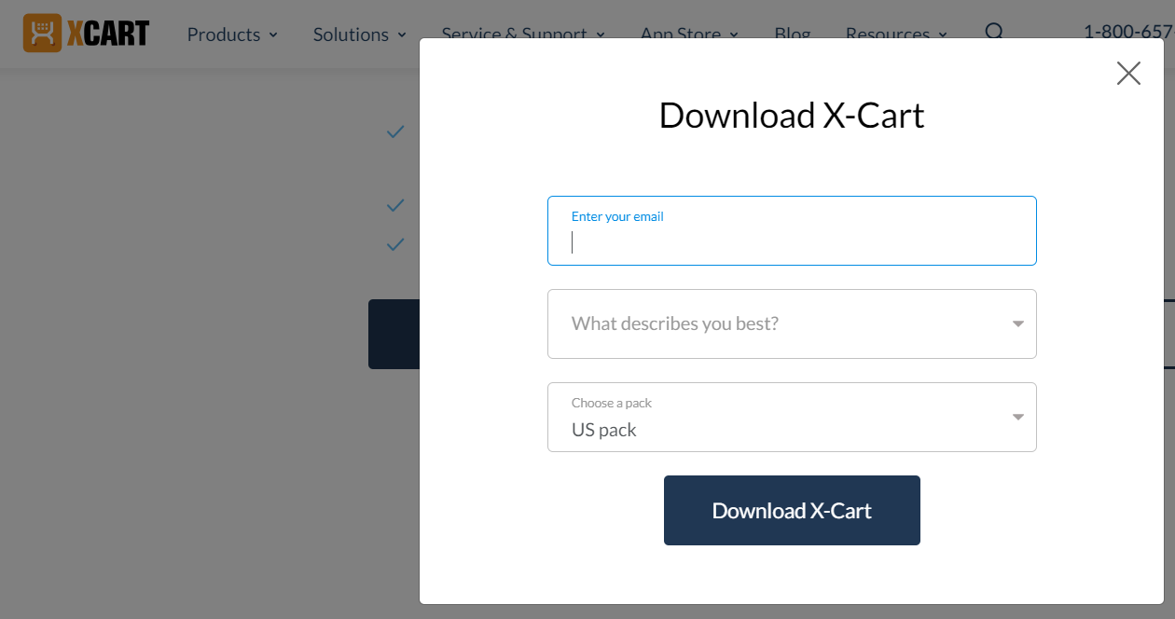

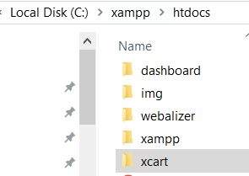Following that, the package was extracted and placed in the “HTDocs folder”. HTDocs is the folder which the virtual server of XAMPP can easily access. If the server would be of a web hosting rather than virtual server on local machine, we might have to use specialize software (file transfer protocol program) in order to upload the setup files on the server.

Now, the Apache server and MySQL service were turned on and the server started running. <http://localhost/xcart/xcart/install.php> was opened in order to run the X-cart installation wizard.

After the installation is completed, we are directly given a glimpse of the two zones for the development:

1. Customer Zone (front-end) >>> http://localhost/xcart/xcart/cart.php
2. 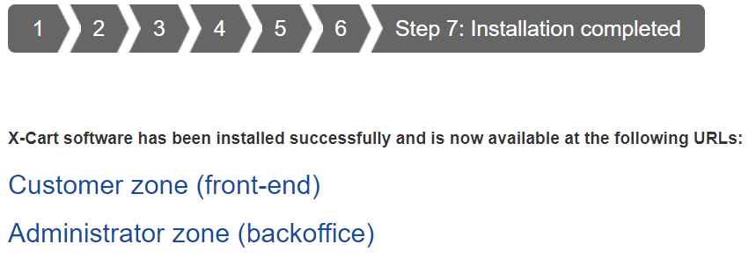Administrator Zone (backoffice) >>> http://localhost/xcart/xcart/admin.php

# First Step!

The process of exploring the X-Cart software started by clicking to the Customer Zone (front-end). This led me to the view of the site that will be visible to the general customers (<http://localhost/xcart/xcart/>).

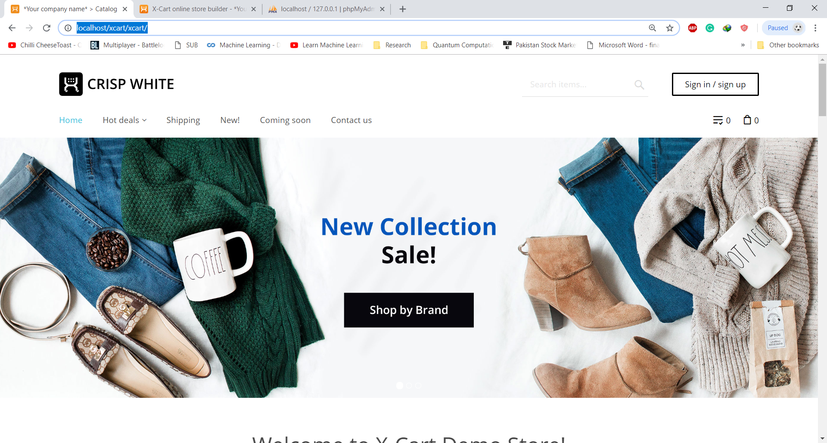

The website was already well built and refined. The most vivid feature being the photo slider with hyperlink to different categories. On further exploration, it was found that the Home, Hot deals which is drop down menu, shipping and Coming Soon had pages while “New!” and “Contact us” pages were not already available. Sign in/out had proper pages build for it as well. Similarly, other pages such as Fashion in Categories were missing as well.

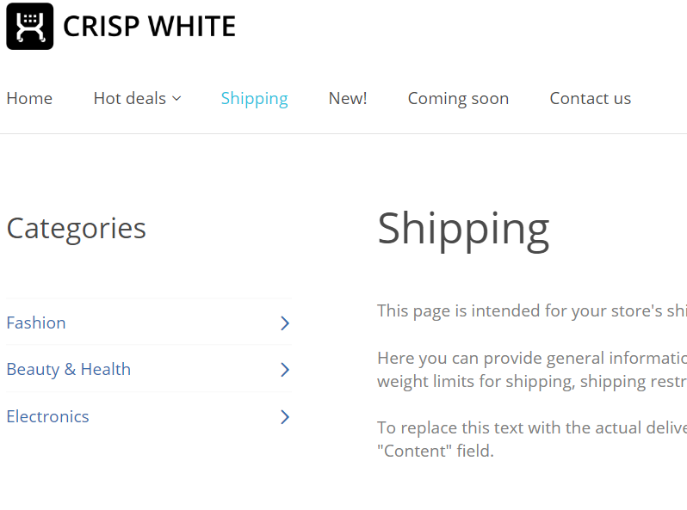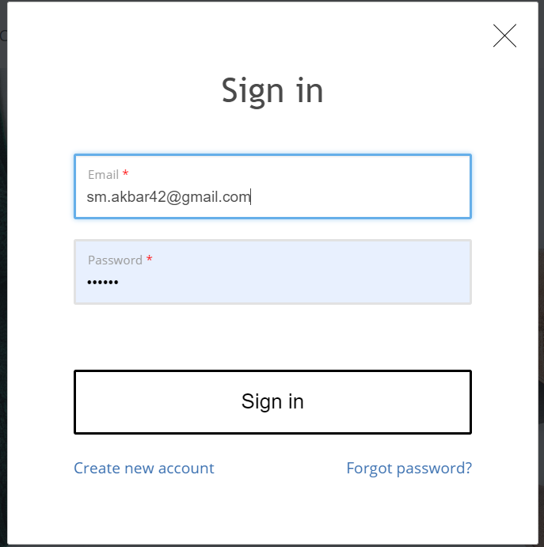

# Administration Zone:

After that we logged into the administration area, we were greeted with overwhelming number of features. However, as went over each and every detail visible on the page things started to connect and make sense.

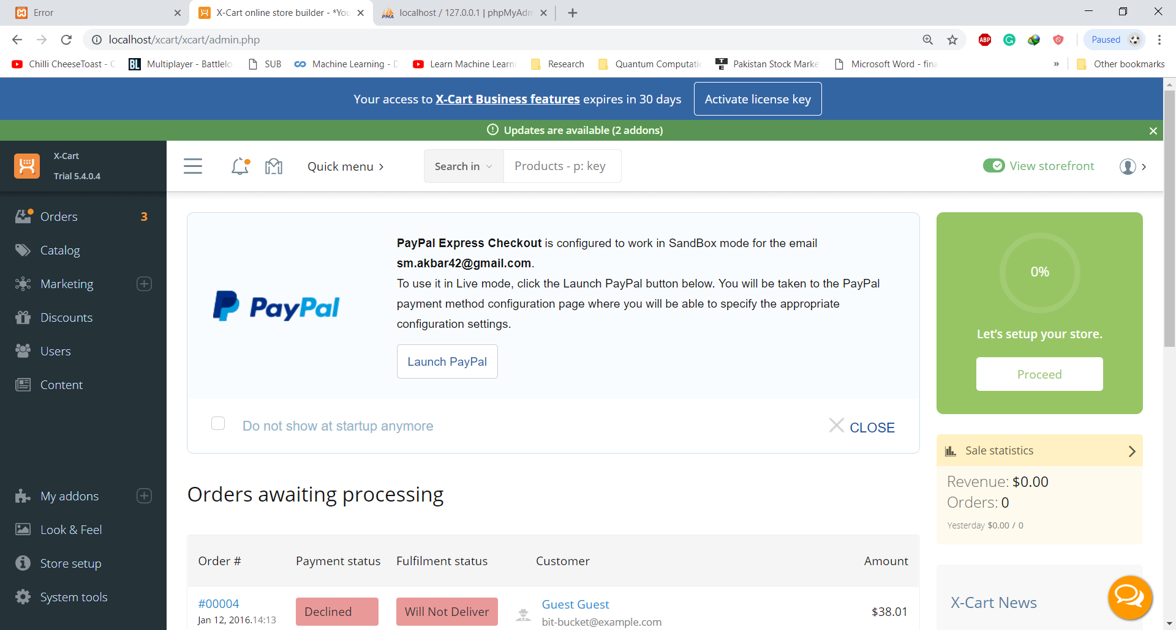

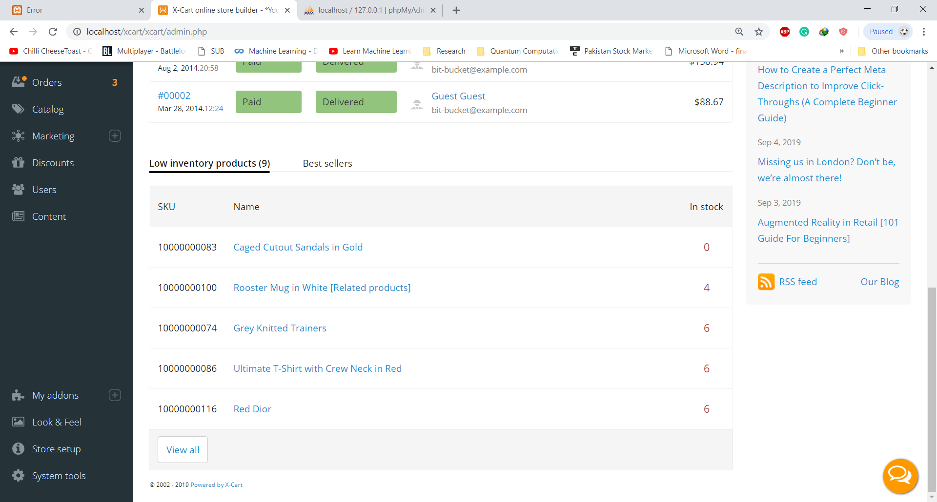

The administration area was divided into 4 parts. The upper bar, left-side (fix) bar, right side status bar and content area at the center.

## Upper bar:

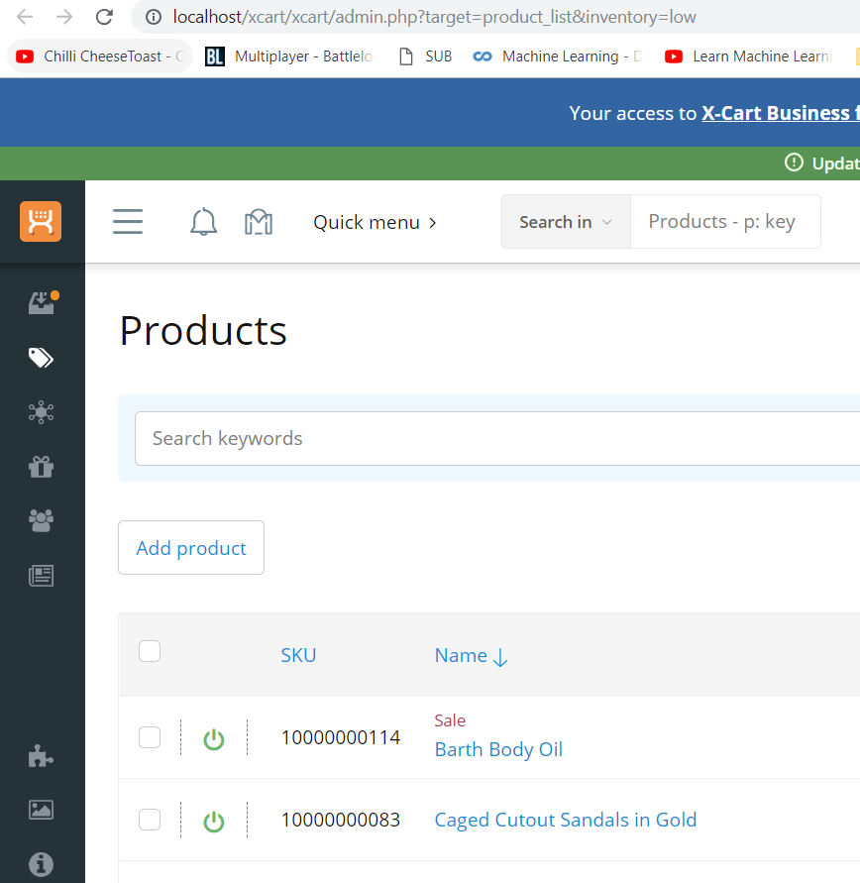The button, starting from the left, was simply to expand and contract (toggle) the side bar description. The button was followed by a notification bell. On hovering cursor on the notification bell, it informs about the products that are short in stock. We can click the message to the product page with filter “inventory = low”. This filter is passed by the means of url: <http://localhost/xcart/xcart/admin.php?target=product_list&inventory=low>

Target = product_list & inventory = low.

Followed by the bell icon, the shopping bag icon is also a kind of notification icon but specific for the market area. Marketplace basically inform you about the opportunities available that can a perform business or start up in any way.

We than have the option to toggle “storfront view” and user icon. Hover over the option displays further options:

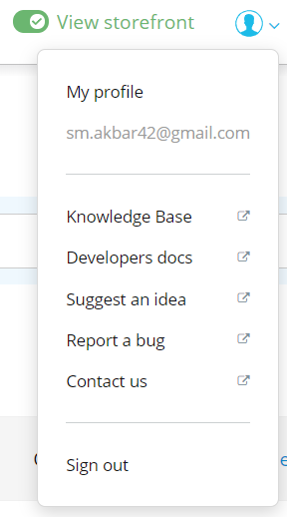

## Side-bar:

The X-cart logo is visible on the top of the side-bar which intuitively takes the user to the home of the system on clicking.

Right below the icon, there are several features available:

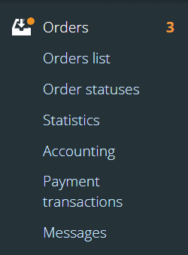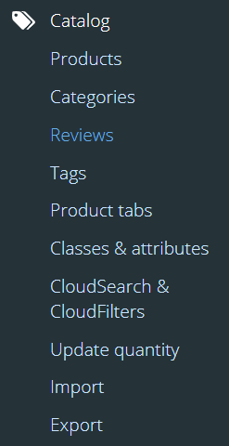

1. Orders: User find it very easy to track the orders pending
2. Catalog: On clicking, a drop-down text menu appears. The menu consists of options to go to: product, categories, reviews, tags, product tabs etc pages. It is a very suitable place to add categories such as fashion or books, add products with in the categories such bag under the category fashion, and find all the review in one place.
3. Then again, we have a Marketing place where we can buy exclusive or premium features. Such as new button styles.
4. We have Discounts after the marketing. Discount has two simple tools available by default. Volume discount which is the discount based on the total purchase by a customer and coupons that a customer can use to get a discount.
5. Perhaps the most important is the Users. It has list of users, membership levels and roles assigned. It is very important for coherency to remain in a team.
6. 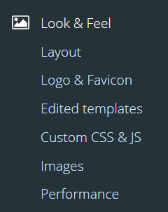Finally, we have Content with news messages, front page, menus and pages options. Each option lets the user edit the named option.

Lastly, the lower section of the side-bar has following features:

1. My addons: to add more addons from the X-cart market place
2. Look & Feel: lets you chane layout, logo etc. It even lets the user add custom CSS & JS code
3. Store setup: deal things more related to the actual location of the shop and delivery service. Since, it is a real shop, this also let you deal with other information such as taxes.
4. Finally, the System tools: It lets you deal with the environment, Cache Management, Database, Integrity check etc.

## Statistics (Right)

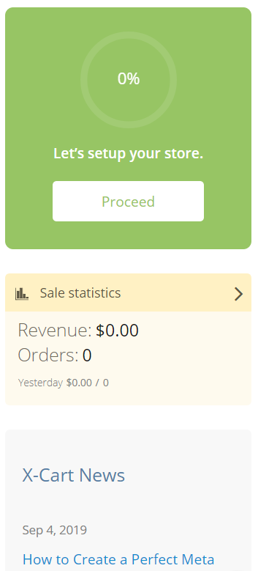The area on the right seems to be only present in the home page. As soon as we transition from the home page to any other, the statistics column disappears. As name given (by me), this deals with sale statistics and news. Another very cool feature is the store setup percentage. This feature tells the progress you have made in building a professional ecommerce website. With the line “Let’s setup you store” and “proceed” button right below, it really gives a feel that if we click on the proceed button, we may actually be able to develop the website completely.

## Content Area:

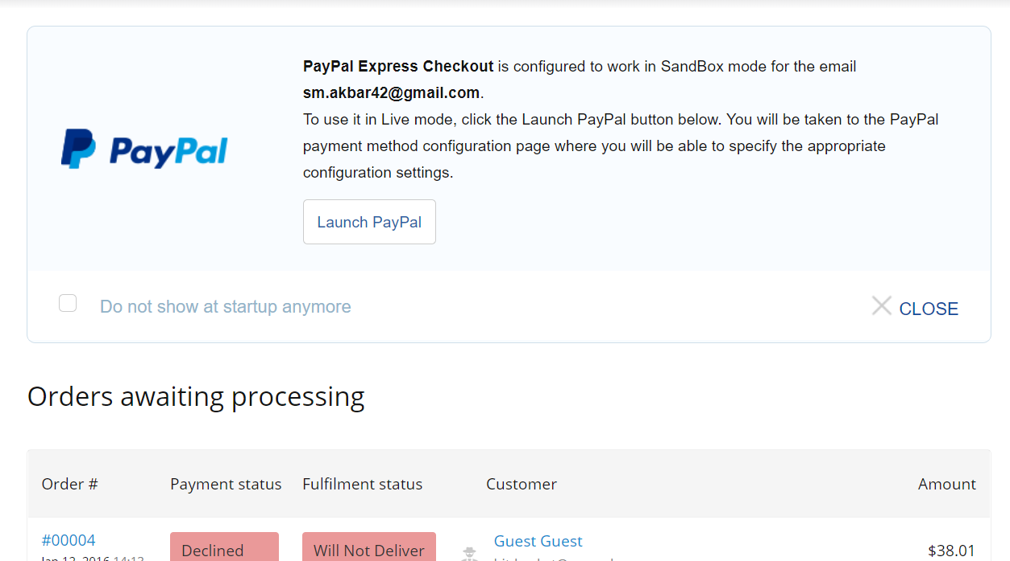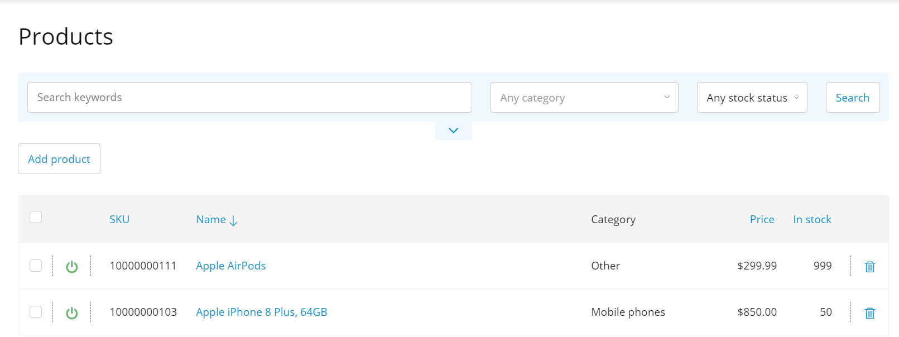Basically, it is the main content area of the software. The content in this area depends on the types of options or web pages you have decided to access.

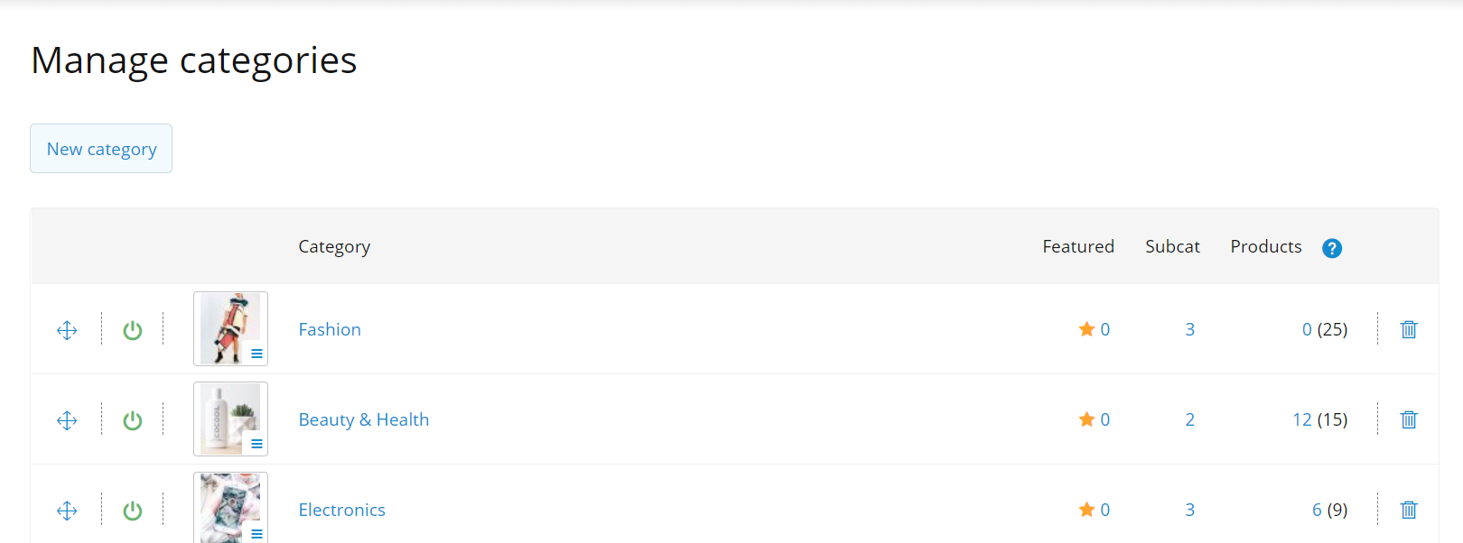

# Databases

X-cart is a database-based framework. In fact, it is essential to already have an empty database setup with the same name which the user wants to use for the X-cart otherwise there will be an error and the installation will not progress.

The default database of X-cart has tones of different tables with various fields. The default database is thoroughly rationalized with complete information being distributed over several tables, for example there are 8 tables to accommodate “category” alone.

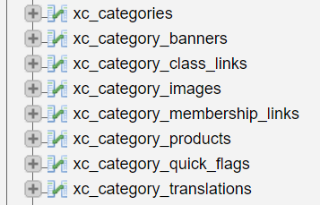

Moreover, it is also fascinating how the table are used to store the images and videos in the X-cart database.

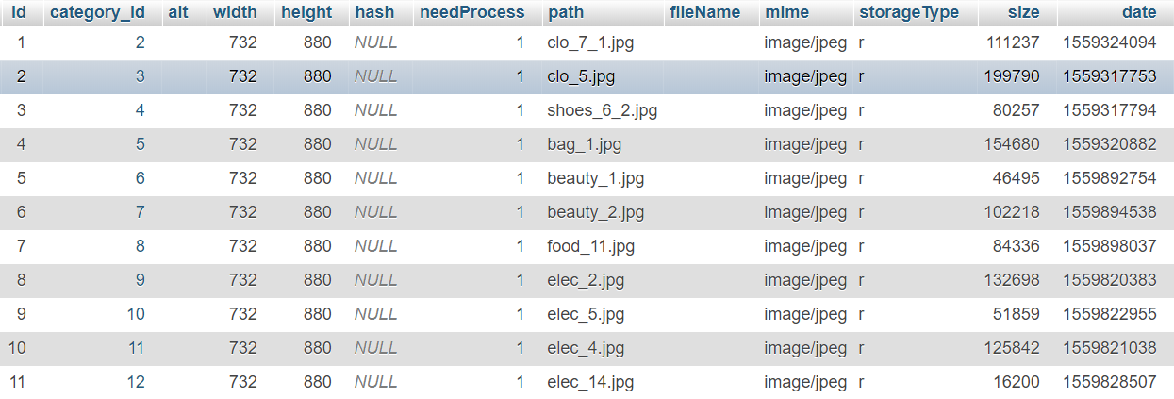

It is the particularly obvious with screen of the table of category images that how the framework handles storing images with the help of dataset and what part is played by the PHP script. First of all, every image is stored with a category id. This mean the when we open a specific category on the webpage, the server generates a query to extract all the rows from the table with that particular category id. Now, this data is used to display the images. The width and height data is used to adjust the dimension of the image. And the path is used to find the image.

It also very fascinating the way they have stored the path of the image. We observe closely, the path of the image is not actually a complete path but the name of the image. This derives two possibilities. First of all, all the images are at root directory which very unlikely while the second possibility is that the php script already have the hardcoded path to image folder so with the image name it will be able to obtain the image. This is a very good practice as if the location of the image folder is change, the only change will be in the one line script of the php code otherwise they might have to alter the all the data in the table.

# Modules

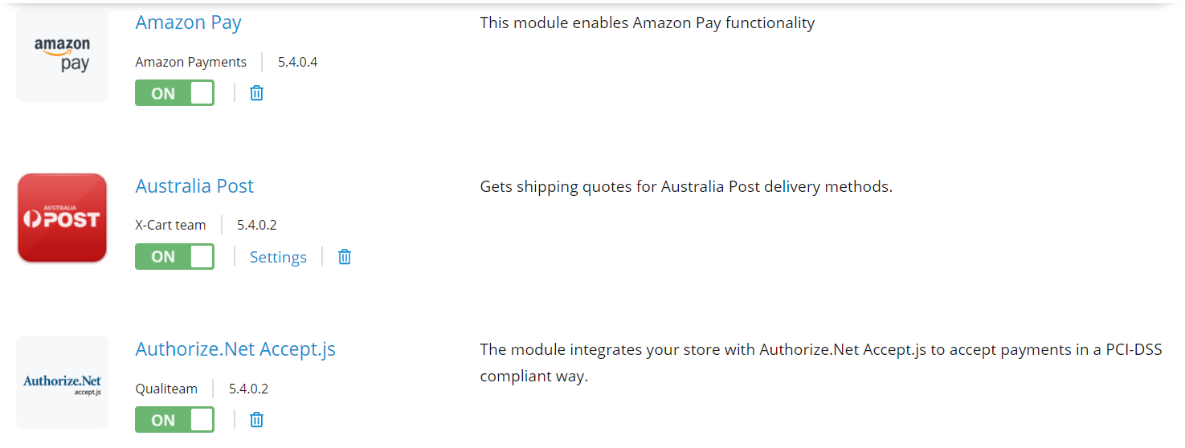The framework is not just code and databases made from scratch but it also a combination of multitude of varying addons.

These are some of many default modules / addons. It can easily be concluded that the payment, shipping and security of the framework is support by my external modules which makes it an overall complete framework.

No matter, how diligently a system is designed it can never be complete in a sense that it can accommodate the requirements of every single user. Therefore, it is necessary that the open source software can easily and seamlessly be expanded. In modern times, this has been achieved with help of addons or plugins. X-cart has many different addon available that can be taken from the x-cart market for free or price. However, it is not only the availability that matters but also the seamless installation.

For installing addons we simply had to click the addon button on the sidebar which lead to the market.

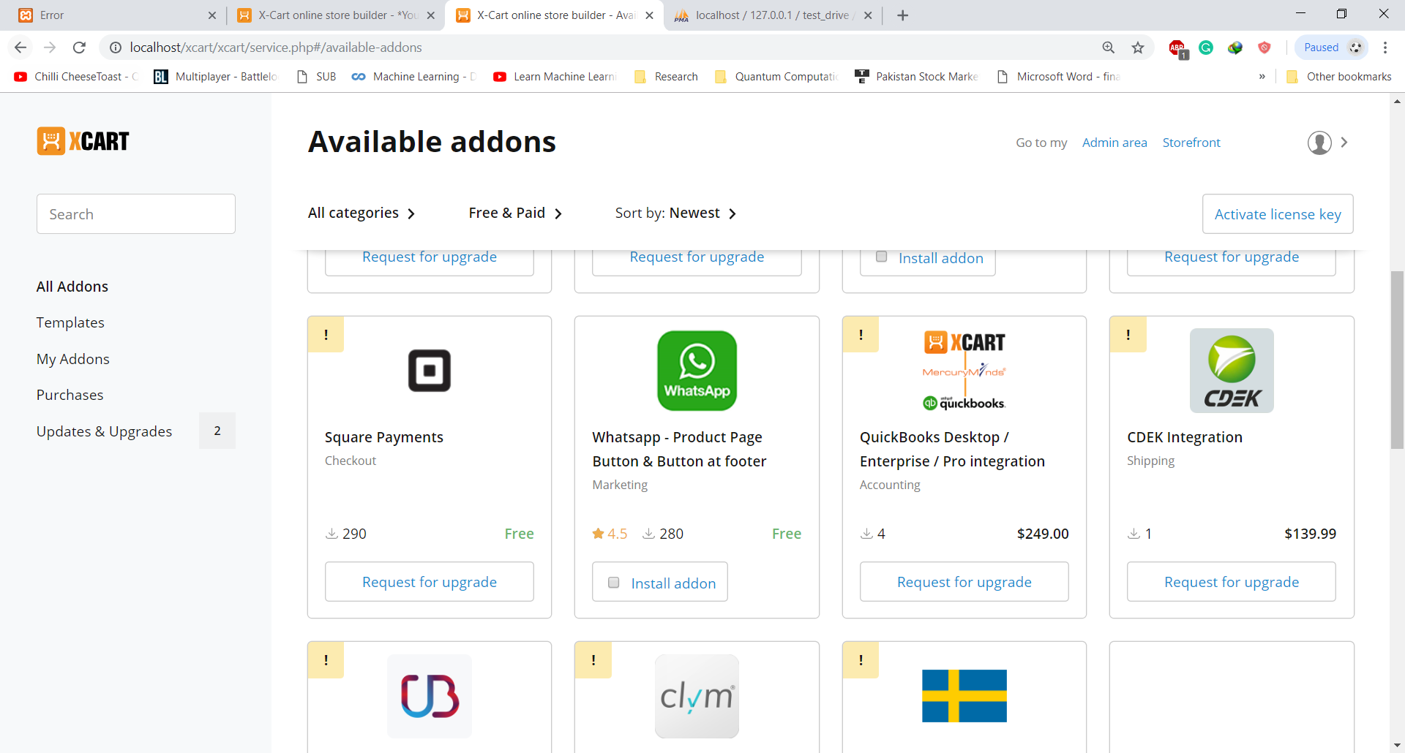

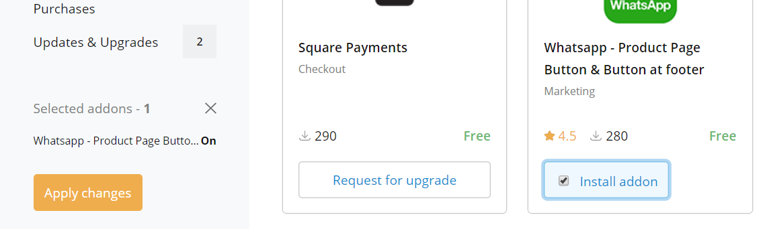For the purpose of the exploration, installing simple and quick application with real world work improvement plugin will do the job. Therefore, WhatsApp plugin was the right addon to go for.

As soon as we check the box of the WhatsApp, a button appears mentioning “Apply changes”. We decide to go ahead. Installation begins:

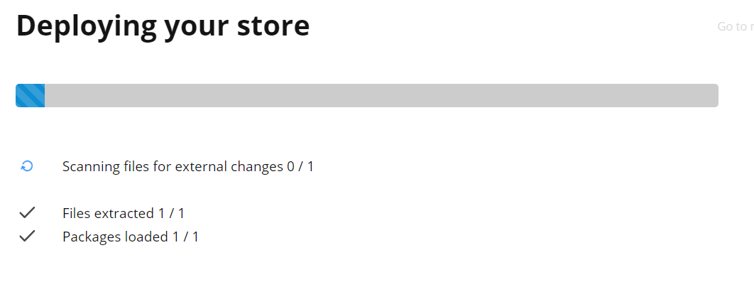

Unfortunately, the efforts of deploying this addon failed the first. When tried on another day, the progress was better than before but unfortunately it got stuck again. It ultimately ended up as a failure. During my search online, it was mentioned the new modules are installed in a matter of few minutes. However, I gave a few hours during a period of few days.

However, on the final day of deadline I found a way to install the module. All you have to do is to close the page when the progress is stuck then open the marketplace. After that click on redeploy and the progress will continue. Finding this way of installing the modules was just luck and the process is not seamless at all!

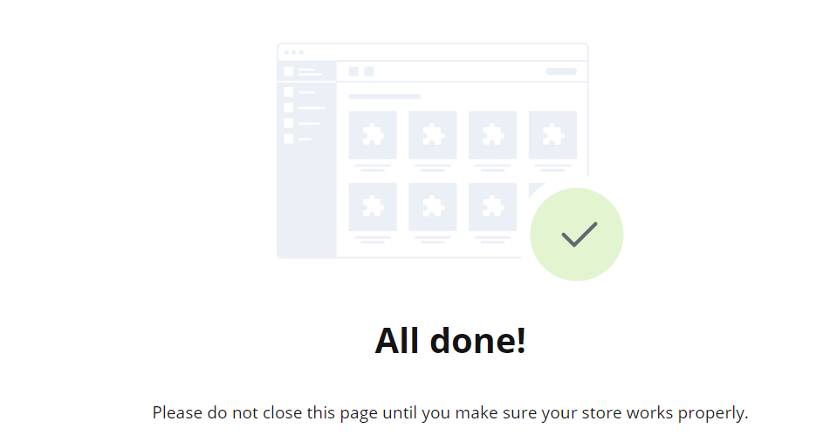

However, once install, the addon become a part of the library of install addons. It also an addition feature “setting” with was not present in other preinstall modules.

However, Setting prove be just the details of the WhatsApp such as country code, phone no. and name. Once that was done. The WhatsApp was integrated on website and became visible to customers.

